**WHERE CLAUSE:**

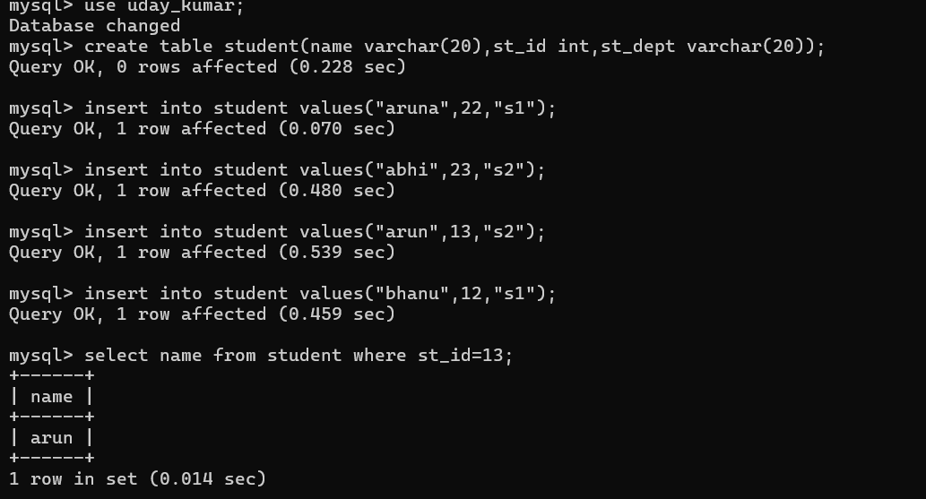

**PATTERN MATCHING:**

